
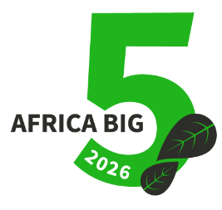
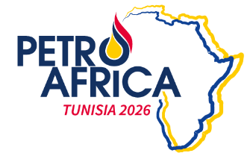


Guidelines for Abstract Submission
PETROAFRICA Tunisia 2026
June 16th-19th 2026, El Kram Expo Center

PETROAFRICA 2026 Topics:
1. Green Energy Systems & Infrastructure
Innovations in renewable energy technologies, hybrid systems and resilient energy infrastructure
2. Green Petrochemicals & Gas Flaring Valorization
Innovative approaches to convert flared gas into sustainable fuels and chemicals reduce emissions and promote carbon economy.
3. Circular Economy & Sustainable Development
Promoting resource effienvy, waste-to- value solutions. and sustainable industrial and urban systems.
4. Policy, Governance & International Cooperation.
Regulatory framework, incentives and global collaboration to accelerate the green energy transition.
5. Decarbonization & Energy Justice
Strategies for Decarbonization, carbon management, and equitable access to sustainable energy.
6. AI & Downstream Petrochemical Operations
Optimizing refining and petrochemical process through AI, predictive maintenance, and energy efficiency solutions.
7. AI & Upstream Oil & Gas Operations
Enhancing exploration, drilling, production, and reservoir management through AI, predictive analytics, and digital twins.
8. Education, Capacity Building & Public Engagement
Developping green skills, raising awareness, and empowering for climate action.
9. Integrated Systems & Cross-Sector Synergies
Innovative solutions for sector coupling, Power-to-X, and achieving Net-Zero targets across industries.

Submission Deadlines:

- March 25th 2026 Abstracts submission Deadline.
- April 5th 2026 : Abstract Acceptance Notification
- April 24th 2026 : Presentation Submission
- May 05th 2026 : Presentation Acceptance Notification

Submission Guidelines
Ensure your abstract adheres to the conference theme
Other formats are not accepted for submission.
Submit your abstract form via conference@petroafrica.org

Registration fees for acceptance abstracts:
AUTHOR RATES
EARLY BIRD RATES 350 $
OIL & GAS COMPANY RATES 500$
INDEPENDANT RATES 250$
CONSULTANT RATES 250$
UNIVERSITY RATES 250$
CO-AUTHOR RATES 250$
ON LINE PRESENCE 50% DISCOUNT
STUDENT RATES FREE
Abstract Form
PETROAFRICA Tunisia 2026 June 16th-19th in El Kram Expo Center, Tunis-Tunisia
Main Author's Full Name: .....................................................................................................................................................
Job Title: ...................................................................................................................................................................................
Company/Organization: ...........................................................................................................................................................
Email Address: .......................................................................................................................................................................................................................................................
Co-authors: ...........................................................................................................................................................................................................................................................
Phone/WhatsApp Number: ..................................................................................................................................................................................................................
Has this work been presented previously? If yes, please provide details (Conference name, and dates):
.................................................................................................................................................................................................................................................................
Abstract Title: ................................................................................................................................................................................................................................
Topic: ..................................................................................................................................................................................................................................................

Short biography (Max 150 words)

Abstract content (Max 500 words)

